# Assignment -2

|  |  |
| --- | --- |
| Assignment Date | 20 September 2022 |
| Student Name | KRISHNAVENI I |
| Student Roll Number | 723619104018 |
| Maximum Marks | 2 Marks |

**Question-1:**

1. Create a Flask App
2. Add the Home page, About Page
3. Add the Bootstrap
4. Add the Sign in page and App the Signup Page + database connectivity

|  |
| --- |
| **Solution:** |
| **INDEX.js** |

**\*\*\*index.js\*\*\***

function deleteNote(noteId) {

fetch("/delete-note", {

method: "POST",

body: JSON.stringify({ noteId: noteId }),

}).then((_res) => {

window.location.href = "/";

});

}

**\*\*\*base.html\*\*\***

<!DOCTYPE html>

<html>

<head>

<meta charset="utf-8" />

<meta name="viewport" content="width=device-width, initial-scale=1" />

<link

rel="stylesheet"

href="https://stackpath.bootstrapcdn.com/bootstrap/4.4.1/css/bootstrap.min.css"

integrity="sha384-Vkoo8x4CGsO3+Hhxv8T/Q5PaXtkKtu6ug5TOeNV6gBiFeWPGFN9MuhOf23Q9Ifjh"

crossorigin="anonymous"

/>

<link

rel="stylesheet"

href="https://stackpath.bootstrapcdn.com/font-awesome/4.7.0/css/font-awesome.min.css"

crossorigin="anonymous"

/>

<title>{% block title %}Home{% endblock %}</title>

</head>

<body>

<nav class="navbar navbar-expand-lg navbar-dark bg-dark">

<button

class="navbar-toggler"

type="button"

data-toggle="collapse"

data-target="#navbar"

>

<span class="navbar-toggler-icon"></span>

</button>

<div class="collapse navbar-collapse" id="navbar">

<div class="navbar-nav">

{% if user.is_authenticated %}

<a class="nav-item nav-link" id="home" href="/">Home</a>

<a class="nav-item nav-link" id="logout" href="/logout">Logout</a>

{% else %}

<a class="nav-item nav-link" id="login" href="/login">Login</a>

<a class="nav-item nav-link" id="signUp" href="/sign-up">Sign Up</a>

{% endif %}

</div>

</div>

</nav>

{% with messages = get_flashed_messages(with_categories=true) %} {% if

messages %} {% for category, message in messages %} {% if category ==

'error' %}

<div class="alert alert-danger alter-dismissable fade show" role="alert">

{{ message }}

<button type="button" class="close" data-dismiss="alert">

<span aria-hidden="true">&times;</span>

</button>

</div>

{% else %}

<div class="alert alert-success alter-dismissable fade show" role="alert">

{{ message }}

<button type="button" class="close" data-dismiss="alert">

<span aria-hidden="true">&times;</span>

</button>

</div>

{% endif %} {% endfor %} {% endif %} {% endwith %}

<div class="container">{% block content %} {% endblock %}</div>

<script

src="https://code.jquery.com/jquery-3.2.1.slim.min.js"

integrity="sha384-KJ3o2DKtIkvYIK3UENzmM7KCkRr/rE9/Qpg6aAZGJwFDMVNA/GpGFF93hXpG5KkN"

crossorigin="anonymous"

></script>

<script

src="https://cdnjs.cloudflare.com/ajax/libs/popper.js/1.12.9/umd/popper.min.js"

integrity="sha384-ApNbgh9B+Y1QKtv3Rn7W3mgPxhU9K/ScQsAP7hUibX39j7fakFPskvXusvfa0b4Q"

crossorigin="anonymous"

></script>

<script

src="https://maxcdn.bootstrapcdn.com/bootstrap/4.0.0/js/bootstrap.min.js"

integrity="sha384-JZR6Spejh4U02d8jOt6vLEHfe/JQGiRRSQQxSfFWpi1MquVdAyjUar5+76PVCmYl"

crossorigin="anonymous"

></script>

<script

type="text/javascript"

src="{{ url_for('static', filename='index.js') }}"

></script>

</body>

</html>

**\*\*\*home.hml\*\*\***

{% extends "base.html" %} {% block title %}Home{% endblock %} {% block content

%}

<h1 align="center">Notes</h1>

<ul class="list-group list-group-flush" id="notes">

{% for note in user.notes %}

<li class="list-group-item">

{{ note.data }}

<button type="button" class="close" onClick="deleteNote({{ note.id }})">

<span aria-hidden="true">&times;</span>

</button>

</li>

{% endfor %}

</ul>

<form method="POST">

<textarea name="note" id="note" class="form-control"></textarea>

<br />

<div align="center">

<button type="submit" class="btn btn-primary">Add Note</button>

</div>

</form>

{% endblock %}

**\*\*\*login.html\*\*\***

{% extends "base.html" %} {% block title %}Login{% endblock %} {% block content

%}

<form method="POST">

<h3 align="center">Login</h3>

<div class="form-group">

<label for="email">Email Address</label>

<input

type="email"

class="form-control"

id="email"

name="email"

placeholder="Enter email"

/>

</div>

<div class="form-group">

<label for="password">Password</label>

<input

type="password"

class="form-control"

id="password"

name="password"

placeholder="Enter password"

/>

</div>

<br />

<button type="submit" class="btn btn-primary">Login</button>

</form>

{% endblock %}

**\*\*\*sign_up.html\*\*\***

{% extends "base.html" %} {% block title %}Sign Up{% endblock %} {% block

content %}

<form method="POST">

<h3 align="center">Sign Up</h3>

<div class="form-group">

<label for="email">Email Address</label>

<input

type="email"

class="form-control"

id="email"

name="email"

placeholder="Enter email"

/>

</div>

<div class="form-group">

<label for="firstName">First Name</label>

<input

type="text"

class="form-control"

id="firstName"

name="firstName"

placeholder="Enter first name"

/>

</div>

<div class="form-group">

<label for="password1">Password</label>

<input

type="password"

class="form-control"

id="password1"

name="password1"

placeholder="Enter password"

/>

</div>

<div class="form-group">

<label for="password2">Password (Confirm)</label>

<input

type="password"

class="form-control"

id="password2"

name="password2"

placeholder="Confirm password"

/>

</div>

<br />

<button type="submit" class="btn btn-primary">Submit</button>

</form>

{% endblock %}

**\*\*\*_init_.py\*\*\***

from flask import Flask

from flask_sqlalchemy import SQLAlchemy

from os import path

from flask_login import LoginManager

db = SQLAlchemy()

DB_NAME = "database.db"

def create_app():

app = Flask(__name__)

app.config['SECRET_KEY'] = 'hjshjhdjah kjshkjdhjs'

app.config['SQLALCHEMY_DATABASE_URI'] = f'sqlite:///{DB_NAME}'

db.init_app(app)

from .views import views

from .auth import auth

app.register_blueprint(views, url_prefix='/')

app.register_blueprint(auth, url_prefix='/')

from .models import User, Note

create_database(app)

login_manager = LoginManager()

login_manager.login_view = 'auth.login'

login_manager.init_app(app)

@login_manager.user_loader

def load_user(id):

return User.query.get(int(id))

return app

def create_database(app):

if not path.exists('website/' + DB_NAME):

db.create_all(app=app)

print('Created Database!')

**\*\*\*auth.py\*\*\***

from flask import Blueprint, render_template, request, flash, redirect, url_for

from .models import User

from werkzeug.security import generate_password_hash, check_password_hash

from . import db

from flask_login import login_user, login_required, logout_user, current_user

auth = Blueprint('auth', __name__)

@auth.route('/login', methods=['GET', 'POST'])

def login():

if request.method == 'POST':

email = request.form.get('email')

password = request.form.get('password')

user = User.query.filter_by(email=email).first()

if user:

if check_password_hash(user.password, password):

flash('Logged in successfully!', category='success')

login_user(user, remember=True)

return redirect(url_for('views.home'))

else:

flash('Incorrect password, try again.', category='error')

else:

flash('Email does not exist.', category='error')

return render_template("login.html", user=current_user)

@auth.route('/logout')

@login_required

def logout():

logout_user()

return redirect(url_for('auth.login'))

@auth.route('/sign-up', methods=['GET', 'POST'])

def sign_up():

if request.method == 'POST':

email = request.form.get('email')

first_name = request.form.get('firstName')

password1 = request.form.get('password1')

password2 = request.form.get('password2')

user = User.query.filter_by(email=email).first()

if user:

flash('Email already exists.', category='error')

elif len(email) < 4:

flash('Email must be greater than 3 characters.', category='error')

elif len(first_name) < 2:

flash('First name must be greater than 1 character.', category='error')

elif password1 != password2:

flash('Passwords don\'t match.', category='error')

elif len(password1) < 7:

flash('Password must be at least 7 characters.', category='error')

else:

new_user = User(email=email, first_name=first_name, password=generate_password_hash(

password1, method='sha256'))

db.session.add(new_user)

db.session.commit()

login_user(new_user, remember=True)

flash('Account created!', category='success')

return redirect(url_for('views.home'))

return render_template("sign_up.html", user=current_user)

**\*\*\*models.py\*\*\***

afrom . import db

from flask_login import UserMixin

from sqlalchemy.sql import func

class Note(db.Model):

id = db.Column(db.Integer, primary_key=True)

data = db.Column(db.String(10000))

date = db.Column(db.DateTime(timezone=True), default=func.now())

user_id = db.Column(db.Integer, db.ForeignKey('user.id'))

class User(db.Model, UserMixin):

id = db.Column(db.Integer, primary_key=True)

email = db.Column(db.String(150), unique=True)

password = db.Column(db.String(150))

first_name = db.Column(db.String(150))

notes = db.relationship('Note')

**\*\*\*views.py\*\*\***

from flask import Blueprint, render_template, request, flash, jsonify

from flask_login import login_required, current_user

from .models import Note

from . import db

import json

views = Blueprint('views', __name__)

@views.route('/', methods=['GET', 'POST'])

@login_required

def home():

if request.method == 'POST':

note = request.form.get('note')

if len(note) < 1:

flash('Note is too short!', category='error')

else:

new_note = Note(data=note, user_id=current_user.id)

db.session.add(new_note)

db.session.commit()

flash('Note added!', category='success')

return render_template("home.html", user=current_user)

@views.route('/delete-note', methods=['POST'])

def delete_note():

note = json.loads(request.data)

noteId = note['noteId']

note = Note.query.get(noteId)

if note:

if note.user_id == current_user.id:

db.session.delete(note)

db.session.commit()

return jsonify({})

# OUTPUT SCREENSHOTS

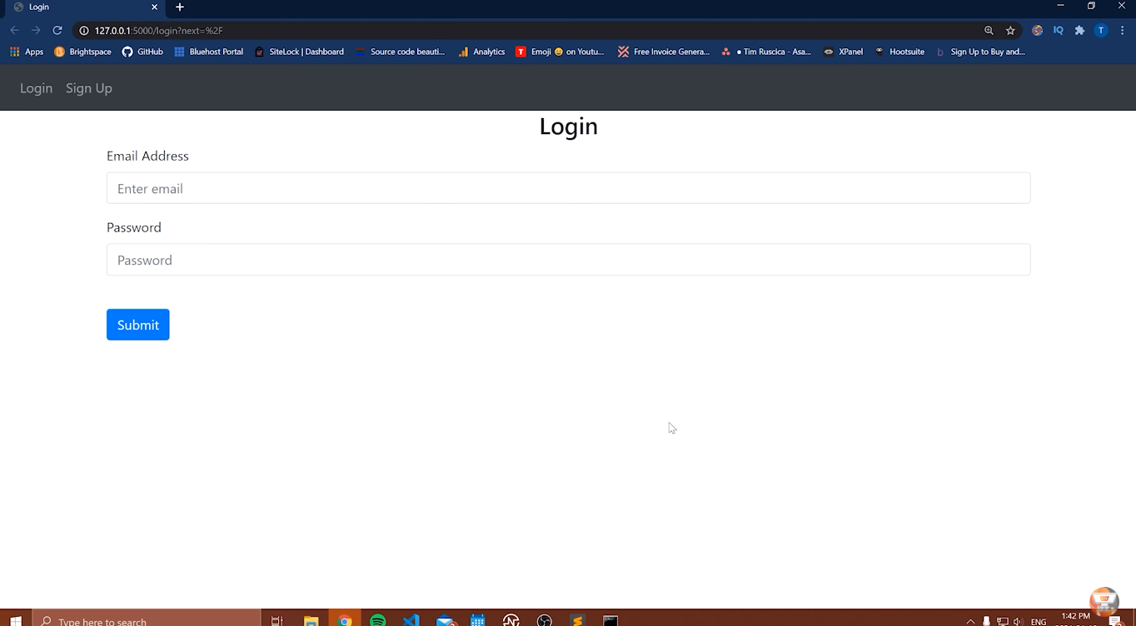 **Step 1 :** enter our email address and password

**STEP 2 :** After enter that click “Login”

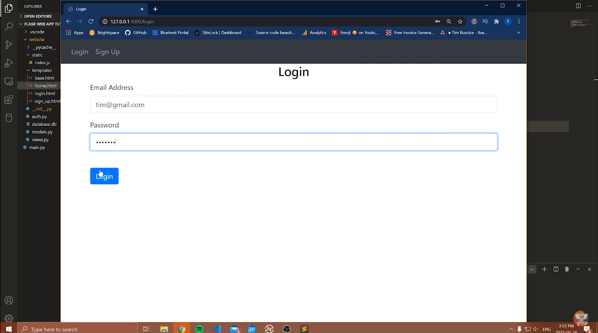

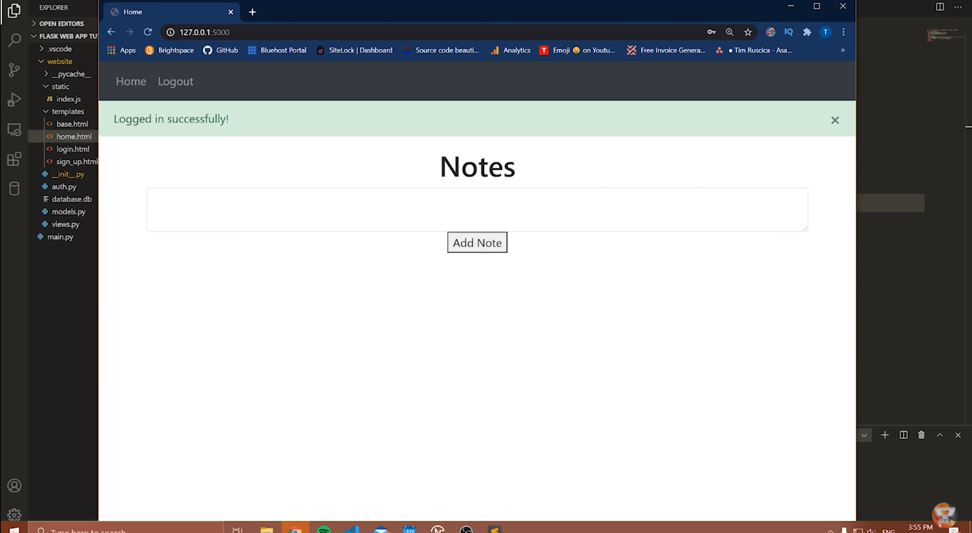Afterthat website redirect you to notes :